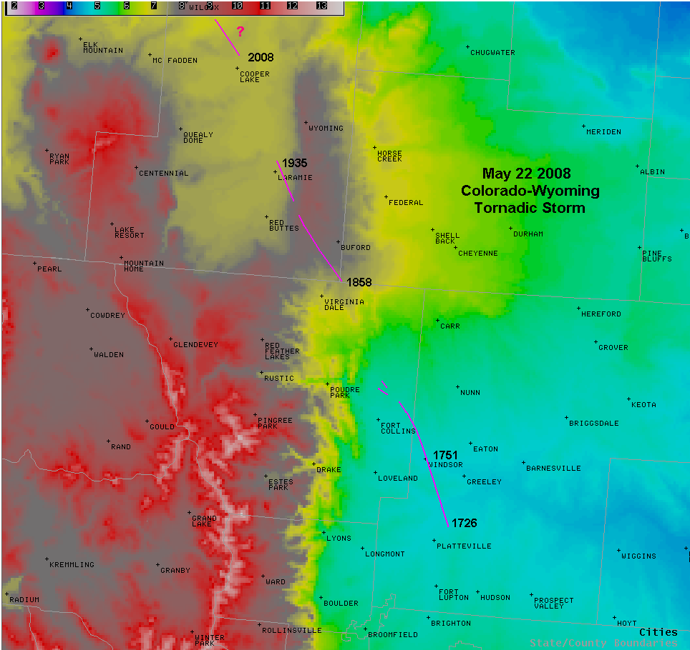

Figure 1. Tornado track associated with the supercell of interest, 22 May 2008. Times plotted next to tornado track (UTC). Elevation (feet) is shaded with scale in upper left. Remove questionable path northwest of Laramie?

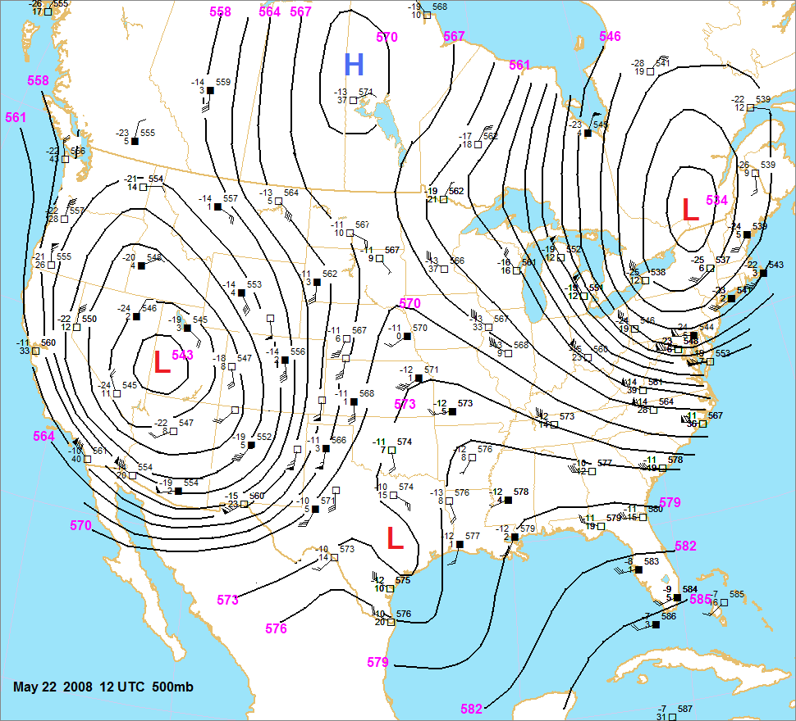

Figure 2. 500 mb analysis from 1200 UTC 22 May 2008. Heights in decameters, temperature and wind observations in °C and knots respectively.

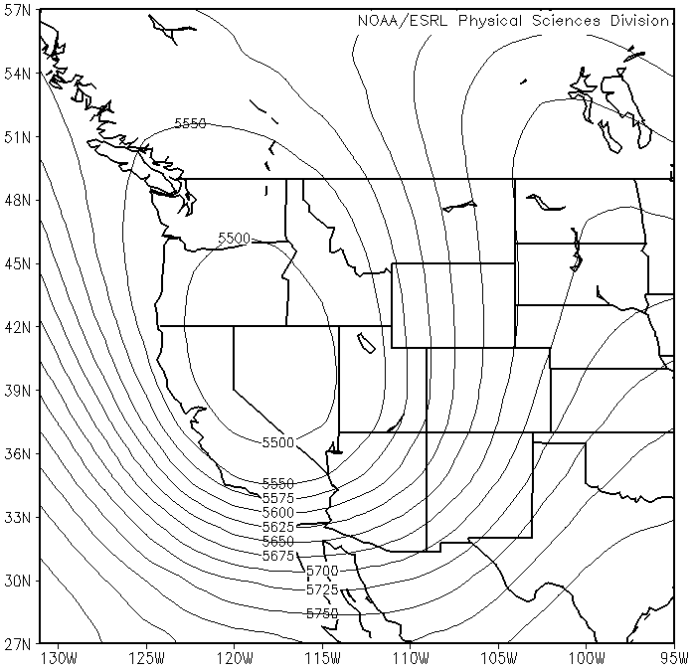

Figure 4. Composite 500 mb heights (m) for 1200 UTC on 22 May 2008, 23 April 1960 and 15 June 1965.

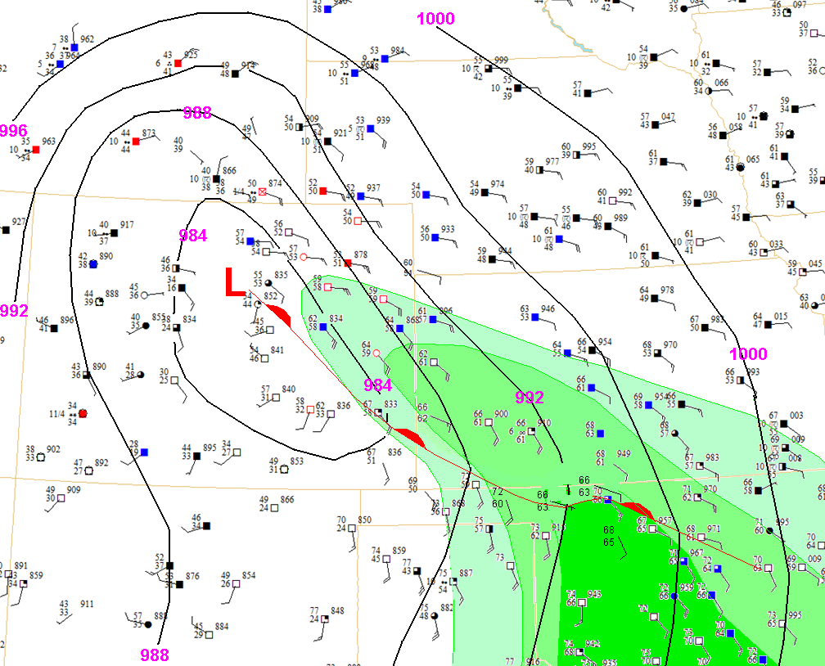

Figure 5. Surface analysis for 0900 UTC on 22 May 2008. Moisture advection highlighted with isodrosotherms of 55 °F, 60 °F and 65 °F shaded from light, moderate, and dark shades of green respectively.
Figure 6. 1545 Visible imagery along with 1600 UTC 22 May 2008 surface observations– show surface observations along with Low, fronts and visible imagery. Does the RUC MSLP look better or just the obs? Need surface boundaries annotated.
Figure 7. Analyzed surface based CAPE (J kg⁻¹) across north central and northeast Colorado, valid 1800 UTC 22 May 2008. Point values indicate locations where modified soundings are derived to estimate surface based CAPE. Perhaps need to show 1700 UTC rather than 1800 UTC?

Figure

Figure 8. Modified sounding for Greeley, CO valid 1800 UTC 22 May 2008. Lifted parcel indicated by turquoise line.
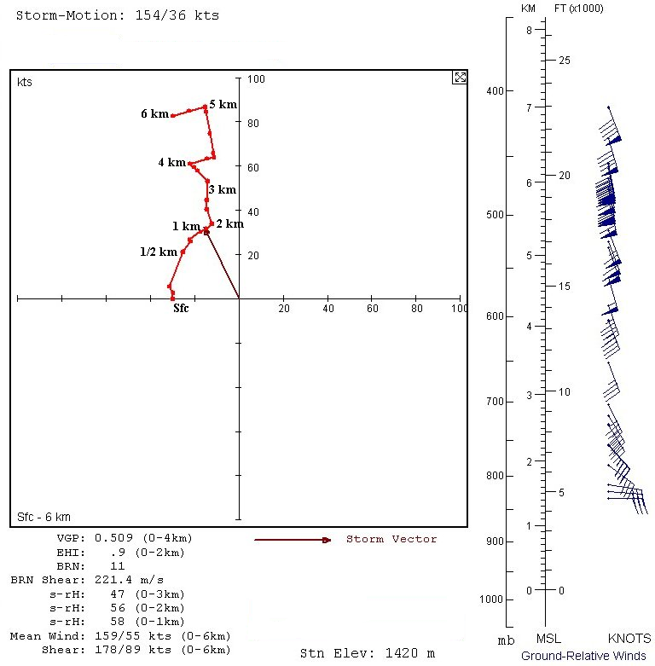

Figure 9. Modified surface to 6 km AGL hodograph for Greeley, CO valid 1800 UTC 22 May 2008. Omit winds on the side and all parameters at the bottom?
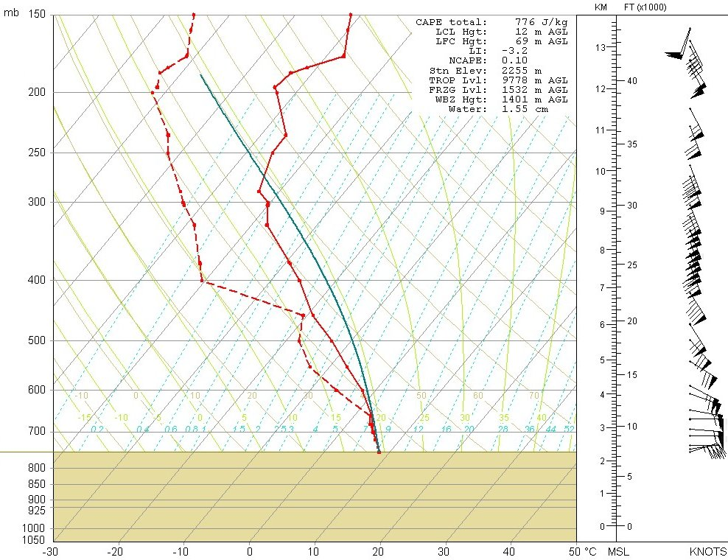

Figure 10. Modified sounding for Harriman, WY valid 1800 UTC 22 May 2008. Lifted parcel indicated by turquoise line.
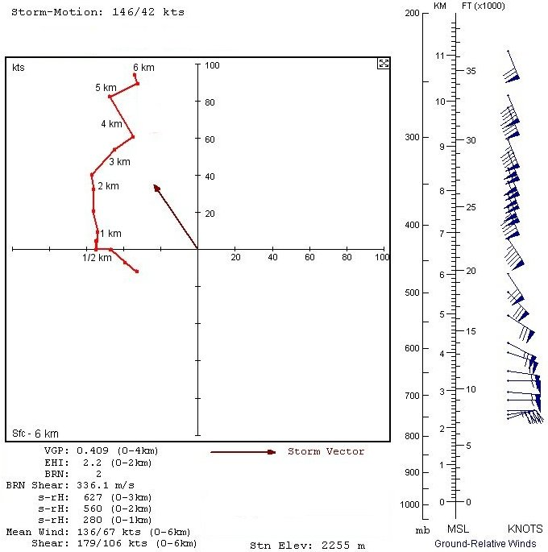
Figure 11. Modified surface to 6 km AGL hodograph for Harriman, WY valid 1800 UTC 22 May 2008. Omit winds on the side and all parameters at the bottom?
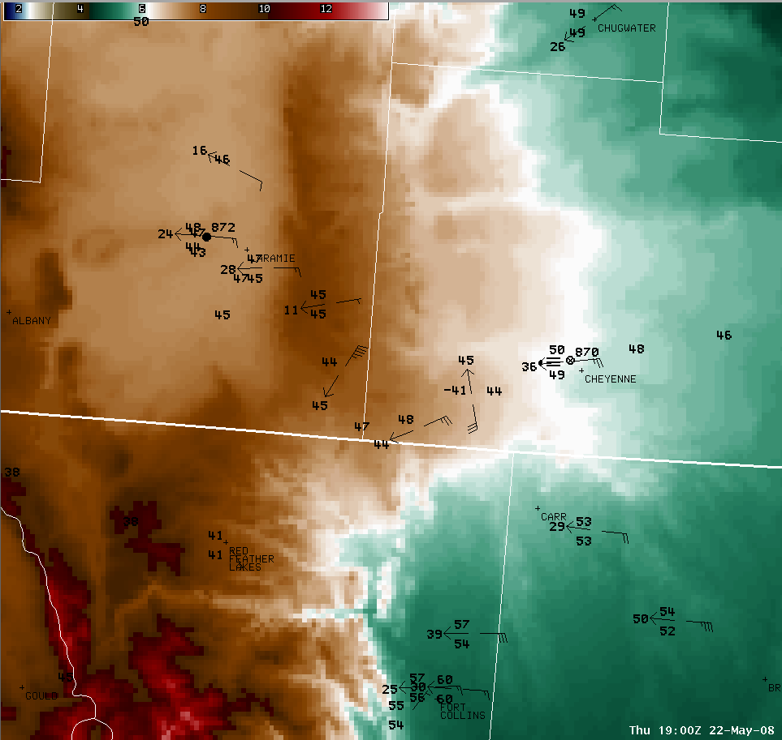

Figure 12. 1900 UTC surface observations with terrain – perhaps get a better (or additional) analysis with Digital Atmosphere?
Figure 13. Observations from a wind tower located along the path of the tornadic storm northwest of Harriman, WY. This tower is located less than one-half mile east of the tornado path. Wind speeds are taken 191 feet AGL, over 10 minute time intervals, in knots. Wind directions are taken at 187 feet AGL, over 10 minute time intervals, in degrees. Green line denotes maximum wind speed, blue line denotes average wind speed and dashed red line denotes wind direction. Times are Mountain Daylight Time. Remember to add the persons name where we got this data in the acknowledgements section

Figure 14. CSU-CHILL radar base velocity at 1.7 ° elevation angle. Times from upper left to bottom right are 1852, 1900, 1907 and 1914 UTC 22 May 2008. Range rings in km from the radar site (located in Greely, CO), the storm of interest is northwest of the radar moving northwest. Scale in m/s. Circle represents the region of stronger winds discussed in the text.

